Unit 1: Rates of Change MVC4U

Lesson Outline

Big Picture

Students will:
- connect slopes of secants to average rates of change, and slopes of tangents to instantaneous rates of change in a variety of contexts;
- approximate rates of change graphically and numerically.
Day | Lesson Title | Math Learning Goals | Expectations
1 | Rates of Change Revisited  GSP® file:  Ball Bounces | - Describe real-world applications of rates of change, e.g., flow, problems using verbal and graphical representations, e.g., business, heating, cooling, motion, currents, water pressure, population, environment, transportations.  - Describe connections between average rate of change and slope of secant, and instantaneous rate of change and slope of tangent in context. | A1.1, A1.2  CGE 2b, 3c, 5a
2 | Determine Instantaneous Rate of Change using Technology  GSP® files, Fathom™ files, and Excel file:  Go with the flow | - With or without technology, determine approximations of and make connections between instantaneous rates of change as secant lines tend to the tangent line in context. | A1.3  CGE 3c, 4b, 4f
3 | Exploring the Concept of a Limit | - Explore the concept of a limit by investigating numerical and graphical examples and explain the reasoning involved.  - Explore the ratio of successive terms of sequences and series, using both divergent and convergent examples, e.g., explore the nature of a function that approaches an asymptote (horizontal and vertical). | A1.4  CGE 2b, 3c, 5a
4–5 | Calculating an Instantaneous Rate of Change using a Numerical Approach  GSP® file:  Secant Slope  (lesson for Day 5 not included) | - Connect average rate of change to and instantaneous rate of change to . | A1.5, A1.6  CGE 3c, 4f
6–7 | Jazz/Summative

Unit 1: Day 1: Revisiting Rates of Change |  |  |  |  | MVC4U
  75 min |  | Math Learning Goals  - Describe real-world applications of rates of change using verbal and graphical representations, e.g., business, heating, cooling, motion, currents, water pressure, population, environment, transportation.  - Describe connections between average rate of change and instantaneous rate of change in context. |  |  | Materials  - chart paper and markers  - computer and data projector  - BLMs 1.1.1–1.1.5
Assessment
Opportunities
 | Minds On… | Groups → Graffiti  Post seven pieces of chart paper each containing a term students encountered in MHF4U. Give each group a different coloured marker.  In heterogeneous groups of three or four students have 30 seconds to write anything they know about the term using numbers, symbols, and/or words. Groups move through all seven charts.  Whole Class → Discussion  Using the four scenarios provided on BLM 1.1.1, review connections between rates of change and the slopes of secants and tangents.  Guiding questions:  - Describe the rate of change of the walleye population over the 25 year period.  - Would you expect half of the water to drain in half the time? Justify.  - What is the rocket’s instantaneous rate of change at four seconds? Describe what the rocket is doing at this point of time.  - Although the Ferris wheel is turning at a constant rate, the rate of change of height is not constant. Explain why. |  | Word Wall  - dependent variable  - independent variable  - finite differences  - slope of secant line  - slope of tangent line  - average rate of change  - instantaneous rate of change  See pp. 66–68  Think Literacy: Cross-Curricular Approaches, Grades 7–12 for more information on Graffiti.  GSP® sketch Ball Bounces.gsp can be used to demonstrate. Make use of an interactive whiteboard, if available.  Consider using a computer lab with GSP® to complete the investigation on BLM 1.1.2.  See pp. 162–165 of Think Literacy: Cross-Curricular Approaches, Grades 7–12 for more information on Frayer Models.
 | Action! | Pairs → Investigation  Curriculum Expectation Observation/Mental Note: Observe to identify students’ ability to make connections between the average rate of change and slope of secant and instantaneous rate of change and slope of tangent.  Students complete the investigation on average and instantaneous rates of change from BLM 1.1.2.  Mathematical Process Focus: Connecting
 | Consolidate Debrief | Whole Group → Discussion  Share findings with the class. Address any misunderstandings.  Guiding Questions:  - Describe how to select points on a curve so that the slope secant better represents the instantaneous rate of change at any point in the interval.  - How would you change the intervals around each bounce to provide better information about the average and instantaneous rates of change of the ball?  Pairs → Pair/Share: Frayer Model  A coaches B in completing a Frayer model for average rate of change. B coaches A in completing Frayer model for instantaneous rate of change (BLM 1.1.4).
Application |  | Home Activity or Further Classroom Consolidation  Gather examples of rates of change from your life using Worksheet 1.1.5.

1.1.1: Revisiting Rates of Change

1.
25-year Walleye Population
Year | Walleye Population
0 | 3000
1 | 3400
2 | 3720
3 | 3976
4 | 4181
5 | 4345
6 | 4476
7 | 4581
8 | 4665
9 | 4732
10 | 4786
11 | 4829
12 | 4863
13 | 4890
14 | 4912
15 | 4930
16 | 4944
17 | 4955
18 | 4964
19 | 4971
20 | 4977
21 | 4982
22 | 4986
23 | 4989
24 | 4991
25 | 4993
2.
A Fish Story

A pond was stocked with a type of fish called "walleye.” The table on the left gives the population of walleye in the pond for the 25 years following the stocking of the pond.
Down the Drain  The plug is pulled in a small hot tub. The table on the right gives the volume of water in the tub from the moment the plug is pulled, until it is empty.
  Draining Water
  from a Hot Tub
  Time (s) | Volume (L)
  0 | 1600
  10 | 1344
  20 | 1111
  30 | 900
  40 | 711
  50 | 544
  60 | 400
  70 | 278
  80 | 178
  90 | 100
  100 | 44
  110 | 11
  120 | 0

Source: http://www.clipsahoy.com/webgraphics/as0963.htm
1.1.1: Revisiting Rates of Change (continued)

3.
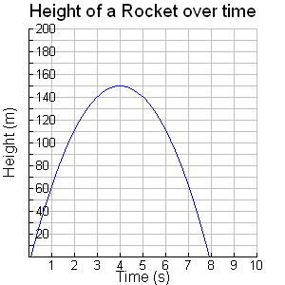 |  | Blast Off  A rocket is launched. The graph shows its height above the ground from time of launching to return to earth.

4.
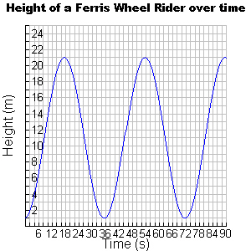 | 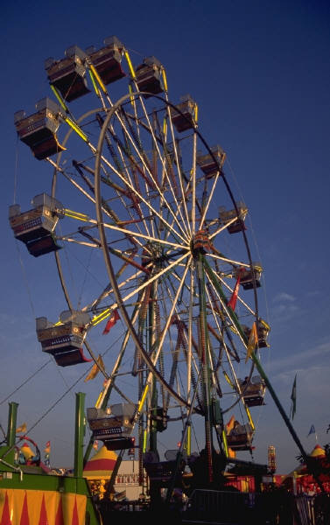

1.1.2: That’s the Way the Ball Bounces!

Kevin dropped a ball and collected the height (m) at various times (s). A graph of the data he collected is provided.

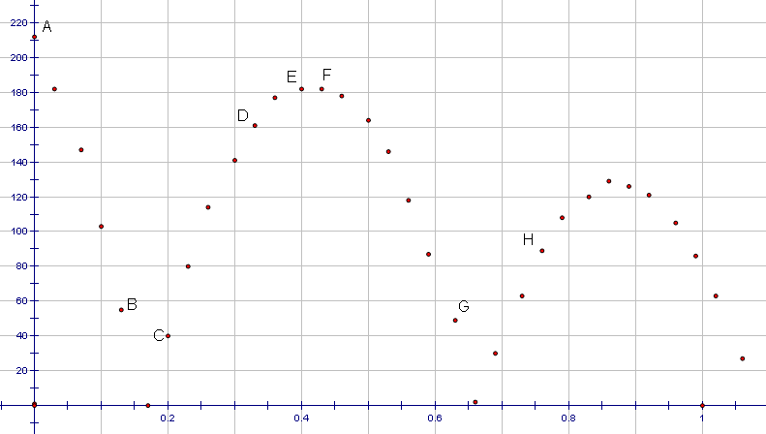

Part A: Average Rate of Change
Kevin wants to look at rate of change of the height at various times. He hopes to determine how quickly the height was changing at various times. Kevin first looks at the average rate of change for specific time intervals. Complete the table with the information in the graph.

Interval | Coordinates of End Points |  | Average  Rate of Change
AB
BC
CD
DE
EF
FG
GH

What do the values for average rate of change tell you about the path of the ball and the speed of the ball?

1.1.2: That’s The Way the Ball Bounces! (continued)

Part B: Instantaneous Rate of Change
Next, Kevin wants to find a point in each interval whose tangent has the same instantaneous rate of change as each secant.

Sketch a curve of best fit for this data in one colour and draw the secants for the intervals in another colour.

For each time interval, locate the point on the graph between the endpoints whose tangent appears to have the same rate of change as the average rate of change for that interval.

1. On the interval AB the average rate of change is ___________. The point whose tangent matches this rate of change is (________, ________). Draw the instantaneous rate of change at this point, if possible.

2. On the interval BC, the average rate of change is ___________. The point that most closely matches this rate of change is (________, ________).

3. On the interval CD, the average rate of change is ___________. The point that most closely matches this rate of change is (________, ________). Draw the tangent at this point, if possible.

4. On the interval EF, the average rate of change is ___________. The point that most closely matches this rate of change is (________, ________). Draw the tangent at this point, if possible.
1.2.2: That’s The Way the Ball Bounces! (continued)

5. On the interval GH, the average rate of change is ____________. The point that most closely matches this rate of change is (______, ______).

Kevin notices some problems for some of the intervals.

a) For which intervals is it difficult to find a matching point?

b) Why is if difficult to find instantaneous rate of change for these intervals?

c) What was happening to the motion of the ball in these intervals?

1.1.3: That’s The Way the Ball Bounces! (Teacher)

The following provides the coordinates of all the data points gathered by the ball bounce experiment.

Time  (s) | Height  (cm)
0.00 | 212
0.03 | 182
0.07 | 147
0.10 | 103
0.13 | 55
0.17 | 0
0.20 | 40
0.23 | 80
0.26 | 114
0.30 | 141
0.33 | 161
0.36 | 177
0.40 | 182
0.43 | 182
0.46 | 178
0.50 | 164
0.53 | 146
0.56 | 118
0.59 | 87
0.63 | 49
0.66 | 2
0.69 | 30
0.73 | 63
0.76 | 89
0.79 | 108
0.83 | 120
0.86 | 129
0.89 | 126
0.92 | 121
0.96 | 105
0.99 | 86
1.02 | 63
1.06 | 27

1.1.4: Frayer Model

Name: ______________________________________Date: _____________________

Definition  Average Rate  of Change | Characteristics
Examples | Non-Examples

1.1.4: Frayer Model (continued)

Definition  Instantaneous Rate of Change | Characteristics
Examples | Non-Examples

1.1.4: Frayer Model Solutions (Teacher)

Definition  Average Rate of Change is the measure of the rate of change for a continuous function over a time interval.  Average Rate of Change | Characteristics  - The rate can be represented as the slope of a secant line between the end points of the interval  - The slope of the secant line is equivalent to the average rate of change  - Cannot be determined over intervals for functions that have non-continuous intervals such as cusps and vertical asymptotes  - The sign of the slope indicates whether a function is increasing or decreasing
Examples  Average speed of a car for a trip  Speed =  Average rate of bacteria growth  Slope of Secant = $\frac{f(a+h)−f(a)}{h}$ | Non-Examples  - Average height  - Average class mark  - Average income of families

1.1.4: Frayer Model Solutions (Teacher)

Definition  Instantaneous Rate of Change is the measure of the rate of change for a continuous function at point on the function.  Instantaneous Rate of Change | Characteristics  - The rate can be represented as the slope of the tangent line to a curve at a particular point  - The slope of the tangent line is equivalent to the instantaneous rate of change  - Cannot be determined when there is a drastic change in the motion of an object such as at the point an object bounces  - Cannot be determined for functions that are not continuous or have vertical asymptotes
Examples  Real-time readout of speed of a car.  Real-time readout of a geiger counter measuring radioactivity  Slope of Tangent to a curve | Non-Examples  - Average rate of change of a function  - Gauges that do not measure rates such as: odometer in a car, altimeter in an aircraft, …

1.1.5: Bringing It All Together

Describe an example in your life that matches each of the following situations. Explain why you believe each situation models the requirements stated.

Use any of the examples or situations different from those discussed in class!

1. Positive average rate of change all of the time.

2. Positive average rate of change sometimes and a negative average rate of change sometimes.

3. Instantaneous rate of change equal to zero at least once.

4. Instantaneous rate of change which cannot be calculated at least once.

GSP® File: Ball Bounces

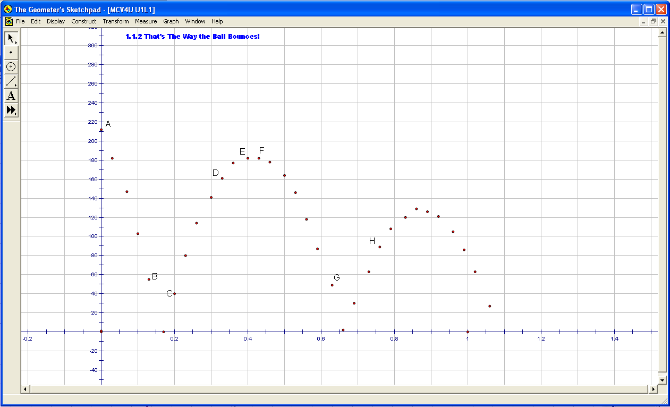

Unit 1: Day 2: Go with the Flow |  |  |  |  | MVC4U
  75 min |  | Math Learning Goals  - Make connections with or without graphing technology between an approximate value of the instantaneous rate of change at a given point on the graph of a smooth function and average rates of change over intervals containing the point.  - Use the slopes of a series of secants through a given point on a smooth curve to approximate the slope of the tangent at the point. |  |  | Materials  - BLMs 1.2.1–1.2.6  - plastic bottles  - 1-2L graduated cylinders or measuring cups  - water  - stop watch
Assessment
Opportunities
 | Minds On… | Pairs → Think/Pair/Share  Use the context of water flowing out of a water reservoir tank and BLMs 1.2.1 and 1.2.2 to activate prior knowledge about average and instantaneous rate of change and to determine what students know about rate of change. |  | Go with the flow.ftm  Go with the flow exemplar.ftm  Go with the flow exemplar2.ftm  Go with the flow.gsp  Go with the flow exemplar.gsp  Go with the flow.xls  Collect and prepare plastic cylindrical containers of various sizes.  Cards (BLM 1.2.4) are available to provide additional scaffolding.  BLM 1.2.5 provides instructions for using technology to graph the data and find slopes of secants.
 | Action! | Small Groups → Investigation  Curriculum Expectation/Observation/Mental Note: Observe to identify students’ ability to make connections between the average rate of change over an interval containing a point and the instantaneous rate of change at a given point.  Students work in groups of three or four using BLM 1.2.3 to understand the instantaneous rate of change of the volume of water as it flows out of a container with respect to time and to recognize this to be the instantaneous rate of flow. Students approximate the instantaneous rate of water flowing from a plastic drink container into a measuring cup or graduated cylinder, using a series of secants to the graph showing the relationship between the volume of water flowing out of the plastic drink container and time.  Differentiating Instruction: The investigation can be changed to “height versus time” by placing a measured tape on the straight side of the container and adjusting the BLM appropriately.  Mathematical Process Focus: Connecting, Selecting Tools and Strategies.
 | Consolidate Debrief | Whole Class → Discussion  Students share results and strategies used to answer the questions in the investigation (BLM 1.2.3). Use the points made by students to consolidate the following:  - The difference between average and instantaneous rate of water flow.  - The connection between average rate of water flow with secants and instantaneous rate of water flow with tangents to the graph.  - The challenge of determining the instantaneous rate of water flow.  - The use of secants (or average rates of water flow) to approximate the instantaneous rate of water flow at a given point in time.
Concept Practice |  | Home Activity or Further Classroom Consolidation  Consolidate your learning (Worksheet 1.2.6).

1.2.1: Think/Pair/Share
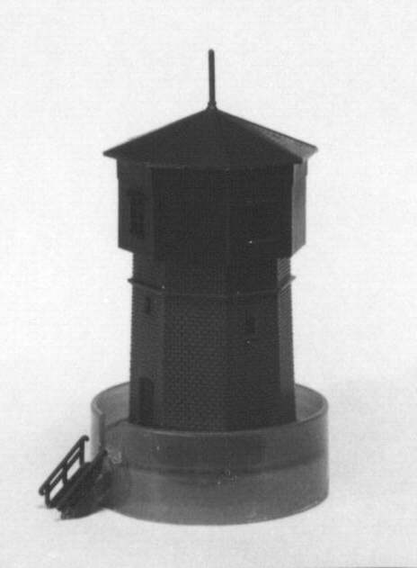
Image source: home.att.net/~berliner-Ultrasonics/bwzsagAa6.html

Context
Answer each question regarding how water will flow out of the water reservoir shown. Assume the tank is cylindrical and the water is draining out of the bottom of the tank.

1. Do you think the rate of flow of the water out of the reservoir tank is constant? Explain your reasoning.

2. Using Worksheet 1.2.2, consider possible models for the relationship between the volume of water flowing out of the reservoir tank and time.
a) Which model(s) would you immediately dismiss and why?

b) Which graph best models the relationship between the total water that has flowed out of the tank and time? Justify your choice.

3. The average rate of flow is a measure of the rate of change of the volume of water that has flowed out of the reservoir over a given time interval. Use the graph chosen above to explain how the average rate of flow changes as the reservoir empties.

4. Describe the difference between an average rate of flow and an instantaneous rate of flow.

1.2.2: Average and Instantaneous Rate of Change

Each graph models a relationship between the total volume (mL) of water that has flowed out of the tank and time(s).

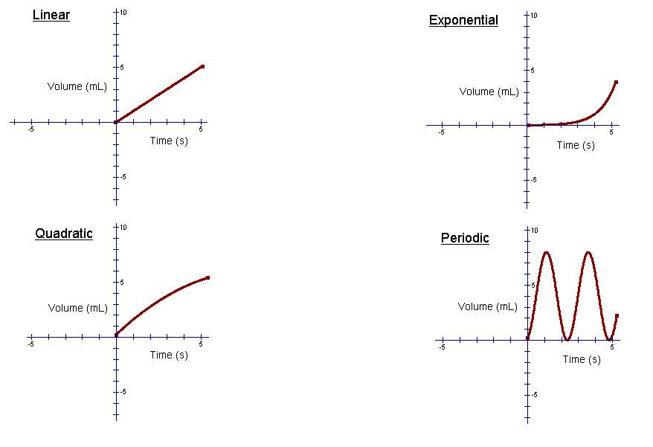

1.2.3: Go with the Flow
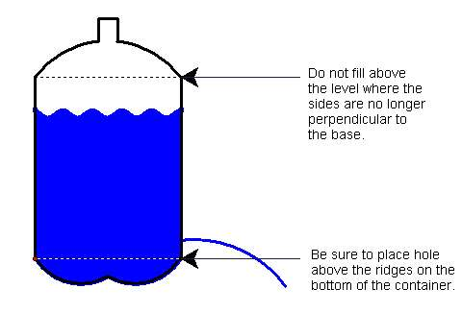

Context: To investigate the rate that water flows out of a cylindrical water tower.

Preparing Materials: Using a plastic drinking container (1.5–2L) make a 3–5 mm hole above the ridges on the bottom of the plastic drinking container. Set up the apparatus as shown in the diagram:

Step One: Gather volume and time data as one litre of water flows out of the plastic drinking container into a measuring cup or graduated cylinder. Record the time at which the volume in the measuring cup reaches a multiple of 50mL in the chart below:
Time  (s) | Volume (mL)
0 | 0
 | 50
 | 100
 | 150
 | 200
 | 250
 | 300
 | 350
 | 400
 | 450
 | 500
 | 550
 | 600
 | 650
 | 700
 | 750
 | 800
 | 850
 | 900
 | 950
 | 1000

Graph the data, Volume versus Time, using graph paper or graphing technology, e.g., graphing calculators, Excel or Fathom™.

Step Two: Construct a curve of best fit with or without technology.

Step Three: Calculate the average rate of water flow over the whole time interval. (Card 1) What connections can you make between the average rate of water flow over the whole time interval and the secant to the graph at the endpoints? (Card 2)

Step Four: Repeat Step 3 choosing two different points on the curve.
What connections can you make between instantaneous flow rates at a specific time and tangents to the graph? (Card 3)
Approximate the instantaneous rate of flow, when 750 mL of water has been collected in the measuring cup, by using your graph and a series of secants containing the point. (Card 4)

Step Five: Specifications for the water tower require that the rate of flow cannot be less than half the initial instantaneous flow rate.
What is the initial instantaneous rate of flow?
Investigate whether or not the rate of flow will meet the required specifications:
- when the container is half full.
- when the container is a quarter full.

Determine the time when the flow rate is exactly half the initial instantaneous flow rate.

1.2.4: Hint Cards

Hint 1

If 200mL flows out of the container in 10 seconds, the average rate that the water flows out of the container is:

Hint 2
A secant is a line that intersects a curve at two points. Find the slope of the secant using the first and last points on the graph. Compare with the average flow rate.

Hint 3
A tangent is a line that makes contact with a curve at one point, without intersecting it.
Find the slope of the tangent using two points on the line. Compare with the instantaneous flow rate.

Hint 4
To use secants to approximate the slope of a given tangent find the slopes of secants with end points on either side of the point of tangency. To get better estimates of the slope of the tangent, make the end points of the secant closer to the point of tangency.

1.2.5: Go With the Flow:
Average and Instantaneous Rate of Change

Analysis of Data using Fathom™
1. Open the data collection: Go with the flow.ftm.
2. Complete Step 1 by clicking on the table and entering each time and volume measurement. Note that because the volume collected is definitely 0 mL at time 0 s, record this data point first. If you are missing some volume-time measurements simply skip them or delete them from the table by right clicking the case number and selecting “Delete case.”
3. Complete Step 2 by dragging the sliders for a, h and k (a is the vertical stretch factor, h is the horizontal shift constant, and k is the vertical shift constant.)
4. Complete Step 3 by dragging the sliders for the time coordinates time_1 and time_2. Adjust the values to draw any secant of your choice. Note the slope of the secant (in the box at the bottom right hand corner of your screen.)

Analysis of Data using Geometer’s Sketchpad®
1. Open the sketch: Go with the flow.gsp.
2. Complete Step 1 by using the Graph menu and selecting Plot Points… Enter the time values as the x-coordinates and the volume values as the y-coordinates. Note that because the volume collected is definitely 0 mL at time 0 s, plot this data point first.
3. Complete Step 2 by dragging the sliders for a, h and k (a is the vertical stretch factor, h is the horizontal shift constant, and k is the vertical shift constant.)
4. Complete Step 3 by dragging point A and point B. Adjust the values to draw any secant of your choice. Note the slope of the secant.

Analysis of Data using Microsoft Excel
1. Open the file: Go with the flow.xls.
2. Complete Step 1 by entering the time values with their corresponding volume values. Note that because the volume collected is definitely 0 mL at time 0 s, this is the first data point.
3. Note that the quadratic curve of best fit has been drawn for you and the equation for this curve is indicated in the bottom right.
4. Print the graph and draw secants as required. Determine the slope of the secant(s) by hand using the graph or the equation to determine the y-values of the points.

1.2.5: Go With the Flow:
Average and Instantaneous Rate of Change (continued)

Go with the flow – Fathom™ file
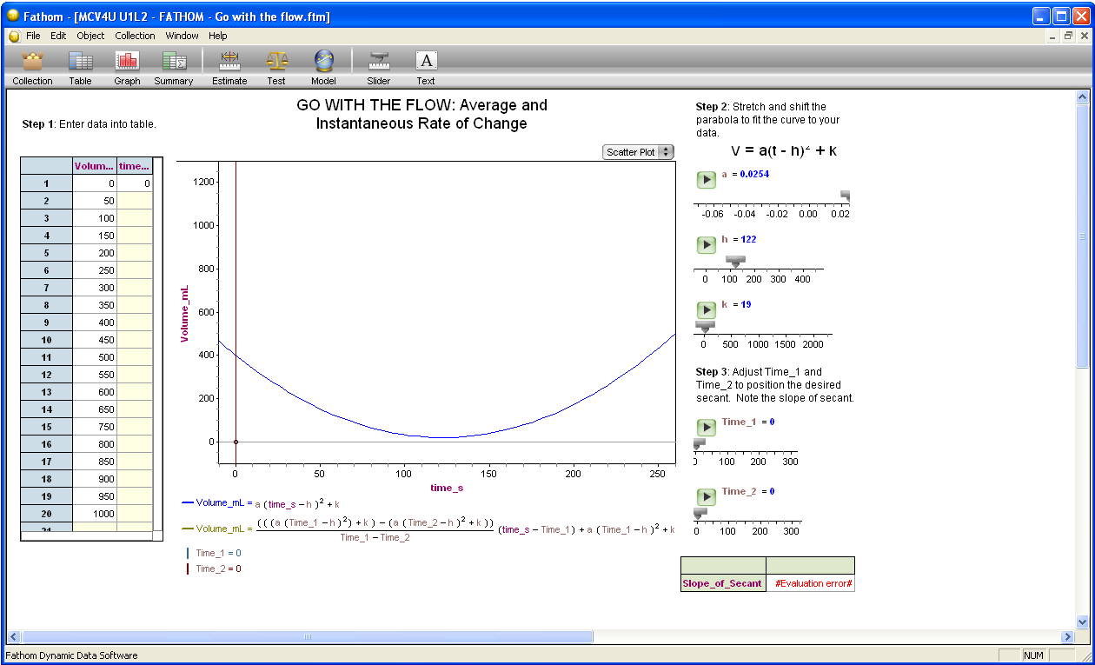

Go with the flow exemplar – Fathom™ file
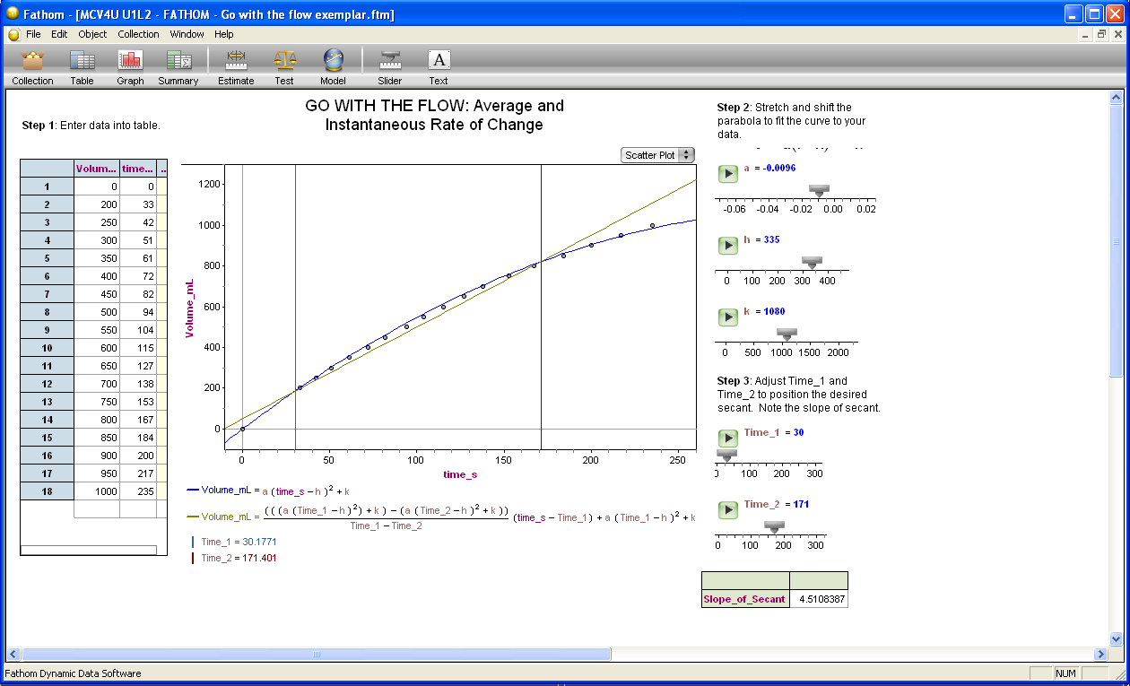

Go with the flow exemplar2 – Fathom™ file
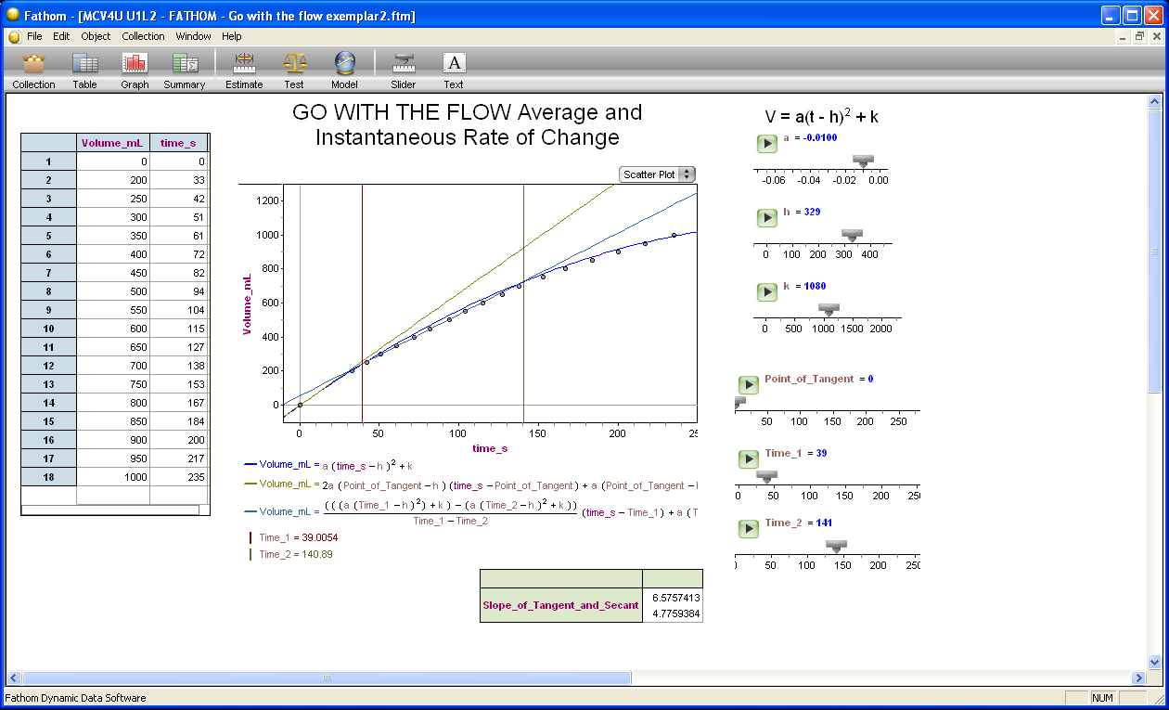
1.2.5: Go With the Flow:
Average and Instantaneous Rate of Change (continued)

Go with the flow – The Geometer’s Sketchpad® file

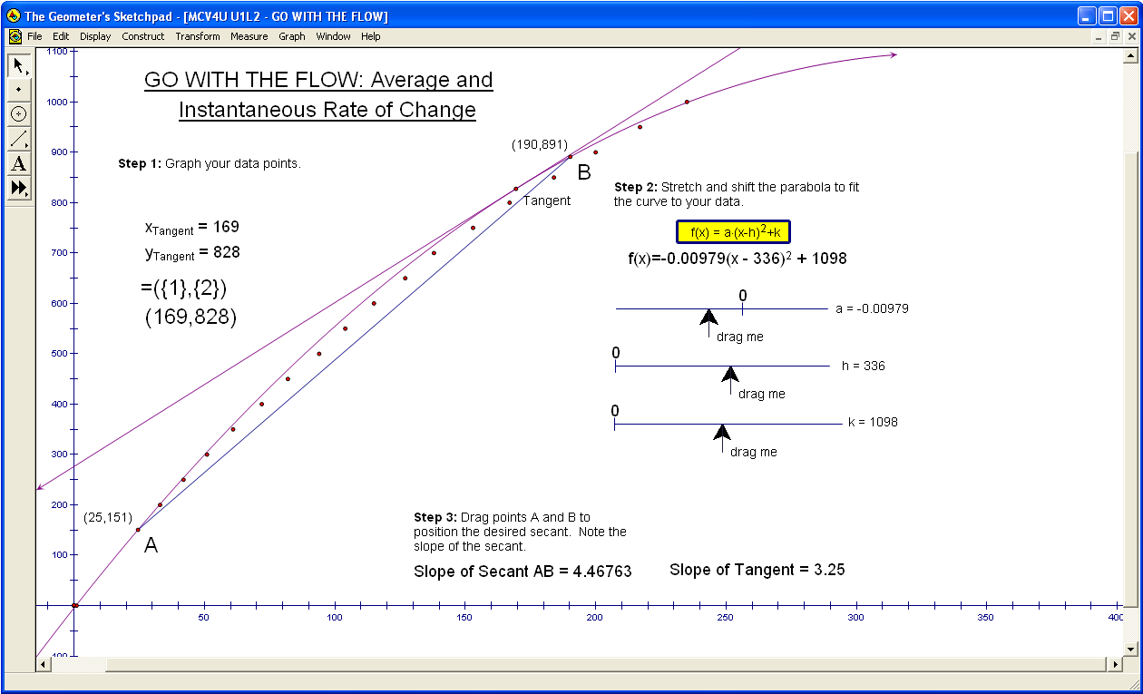

Go with the flow exemplar – The Geometer’s Sketchpad® file

1.2.6: Go With the Flow

Follow Up Activity

For each graph below, find an approximate value for the slope of the tangent at the point A by using a series of secants with A as one endpoint.

Compare and describe the instantaneous rate of change at point A and point B. Explain your reasoning.

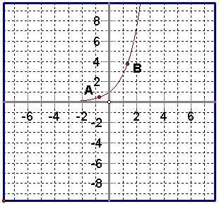 | 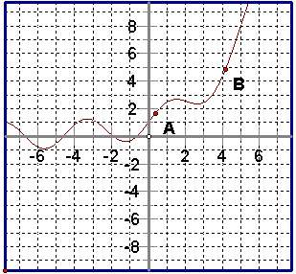
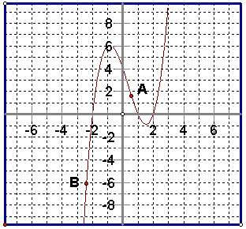 | 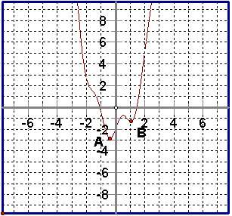

Unit 1: Day 3: Exploring the Concept of Limit |  |  |  |  | MVC4U
  75 min |  | Math Learning Goals  - Explore the concept of a limit by investigating numerical and graphical examples and explain the reasoning involved.  - Explore the ratio of successive terms of sequences and series (use both divergent and convergent examples).  - Explore the nature of a function that approaches an asymptote (horizontal and vertical). |  |  | Materials  - BLMs 1.3.1–1.3.7  - large grid paper  - graphing technology
Assessment
Opportunities
 | Minds On… | Small Groups → Exploration/Discussion  In groups of three using one piece of 8.5 × 11 paper, guide students through the following exploration.  Each group of three divides its paper into four equal pieces and each group member takes one piece.  What fraction of the paper does each group member have?  Divide the remaining piece into four equal pieces and each group member takes one piece.  Ask:  - What fraction of the paper does each group member have?  - If this process continues indefinitely, how much of the paper will each person have? Explain your reasoning.  - How does the graphical representation of the data help to visually explain the concept of the limit?  Whole Class → Instruction  Introduce the vocabulary of “limit” and “infinite sequence” and “infinite series.” |  | Make use of an interactive whiteboard if available.  Students need access to graphing technology and/or large grid paper for each.  Choose examples from BLM 1.3.4 and 1.3.5 for Investigations 1  and 3.  Further information about Fibonacci can be found at:  http://www-history.mcs.st-andrews.ac.uk/Biographies/Fibonacci.html  http://evolutionoftruth.com/div/fibocalc.htm  http://www.mathcentre.ac.uk/staff.php/mathematics/series/limits/resources/resources/366
 | Action! | Small Groups → Investigation  Learning Skill/Observation/Mental Note: Observe students to identify teamwork and work habits.  Each group works on one of the following three investigations. Circulate during the task and provide direction as necessary.  - Investigation 1: Students investigate the concept of a limit using series (BLM 1.3.1 and 1.3.4 (Teacher)).  - Investigation 2: Students investigate the concept of a limit using the sequence of ratios of successive terms the Fibonacci sequence (BLM 1.3.2).  - Investigation 3: Students investigate the concept of a limit using the behaviour of a function near an asymptote (BLM 1.3.3 and 1.3.5 (Teacher)).  Mathematical Process Focus: Reasoning, Representing. Students reason and to make connections between different representations of data and the concept of a limit.
 | Consolidate Debrief | Whole Class → Presentations and Discussion  Groups present their findings from one of their examples. Highlight process and findings.  Present series of graphs showing different representations (data; graphs of discrete data points; graphs of smooth, continuous functions) and summarize the concept of a limit for each (BLM 1.3.6).  Explore further scenarios with series such as 1 – 1 + 1 – 1 + … .
Differentiated Instruction |  | Home Activity or Further Classroom Consolidation  Complete the assigned task (Worksheet BLM 1.3.7).

1.3.1: Taking it to the Limit

In your group, investigate the two examples assigned using the outline below. You may wish to use graphing software to help you with your analysis. Be prepared to present the findings of your group with rationale.

Analysis
To analyse the existence of a limit of these series, create a sequence off partial sums
S₁, S₂, S₃,…,S₁₀, where S₁ represents the sum of the first term
S₂ represents the sum of the first two terms
S₃ represents the sum of the first three terms
.
.
.
S₁₀ represents the sum of the first ten terms


Term Value | Partial Sum for  Series One | Partial Sum for  Series Two
1
2

Select a tool to create a data plot, where n (the sum number) is the independent variable and S_{n} is the dependent variable. Sketch the data plot on the grid provided for one of the sequences for which a limit exists.

Summary

1. State your series _______________________________________

2. State the sequence of sums ________________________________________

3. The behaviour of our sequence is

4. We reached this conclusion because
1.3.2: Investigating Ratios in the Fibonacci Sequence
http://www-history.mcs.st-andrews.ac.uk/Biographies/Fibonacci.html

The Fibonacci sequence is an example of a recursive sequence. Each number of the sequence is the sum of the two numbers preceding it. Formally, this can be written:
1. Complete the following table computing the ratios of consecutive terms correct to 5 decimal places.
Fibonacci Number | Ratio of  Consecutive Terms
1 | 
1
2
3
5
8
13

2. Create a new sequence from the ratios obtained in Question 2, i.e., t₁ = 1, t₂ = 2, t₃ = 1.5 …
1, 2, 1.5, _____, _____, _____, _____, _____, _____, _____, _____, _____, _____
3. Using graphing technology, create a plot of the sequence in Question 2, where the term number is the independent variable and the value of the ratio is the dependent variable. Sketch the graph on the grid provided.
4. Does the sequence of ratios of Fibonacci numbers have a limit? Justify your answer.
1.3.3: Taking it to the Limit

In your group, investigate the two examples assigned using the outline below. You can use graphing software to help you with your analysis. Be prepared to present your group findings with rationale.

Function Analysis
Using the tool of your choice, create a graph for the given domain. Sketch the graph on the grid provided for each of the functions assigned.



Summary
1. State your function. | 1. State your function.
2. Describe the behaviour of the function over the given domain. | 2. Describe the behaviour of the function over the given domain.
3. State the limit if one exists. Explain. | 3. State the limit if one exists. Explain.
1.3.4: Sample Exploration Questions for BLM 1.3.1 (Teacher)

Each group of students receives one series from Group A and one series from Group B.

Group A
Examine 10 sums
Examine 10 sums
Examine 10 sums

Group B
Examine 10 sums
Examine 10 sums
Examine 10 sums

1.3.5: Sample Exploration Questions for BLM 1.3.3 (Teacher)

Each group of students receive one series from Group A and one series from Group B.

Group A

Examine end behaviour as x becomes large.

Examine behaviour as x → 2 (i.e., x gets close to 2) beginning with values x = 1.5 and incrementing by 0.1

Examine end behaviour as x becomes large.

Group B

Examine end behaviour as x becomes large.

Examine end behaviour as x becomes large.

Examine behaviour as x → 0 (i.e., x gets close to 0) for values of x beginning with x = –1 and incrementing by 0.1

1.3.6: Sample Slides for Debrief (Teacher)

1) | 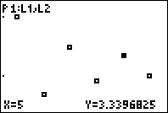
2) | 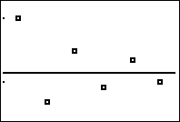

1.3.6: Sample Slides for Debrief (Teacher) (continued)

3. for numbers greater than 0 as compared to
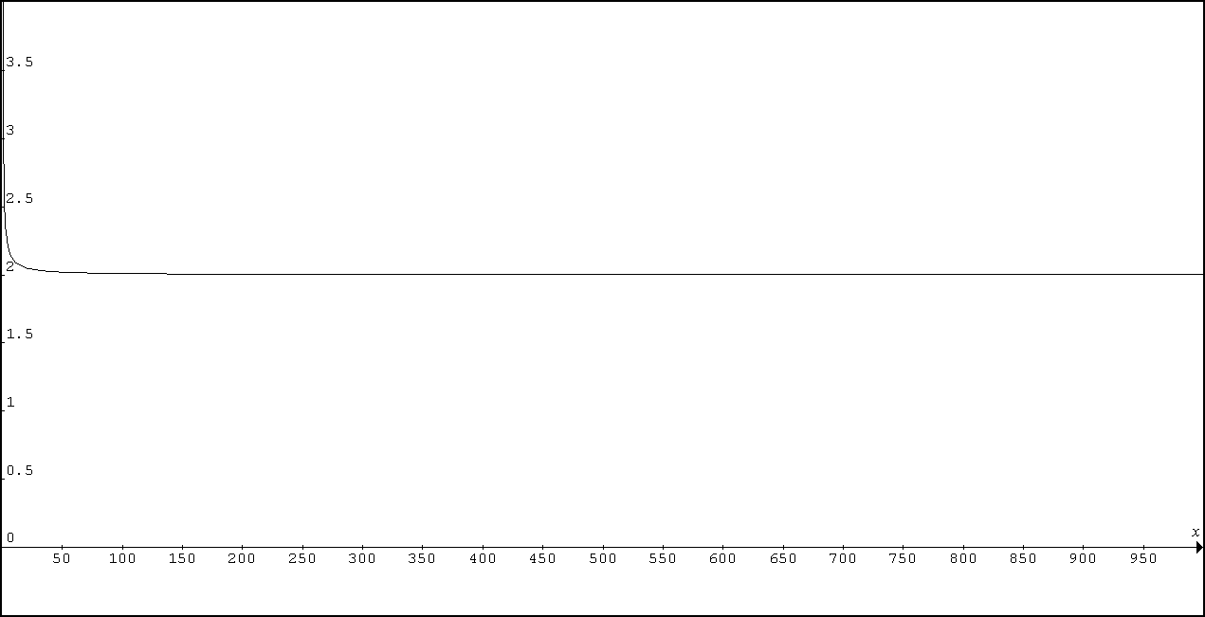

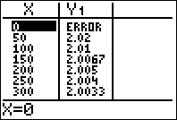 | 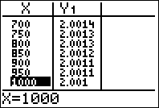 | 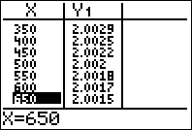

4. Looking at for numbers greater than 3
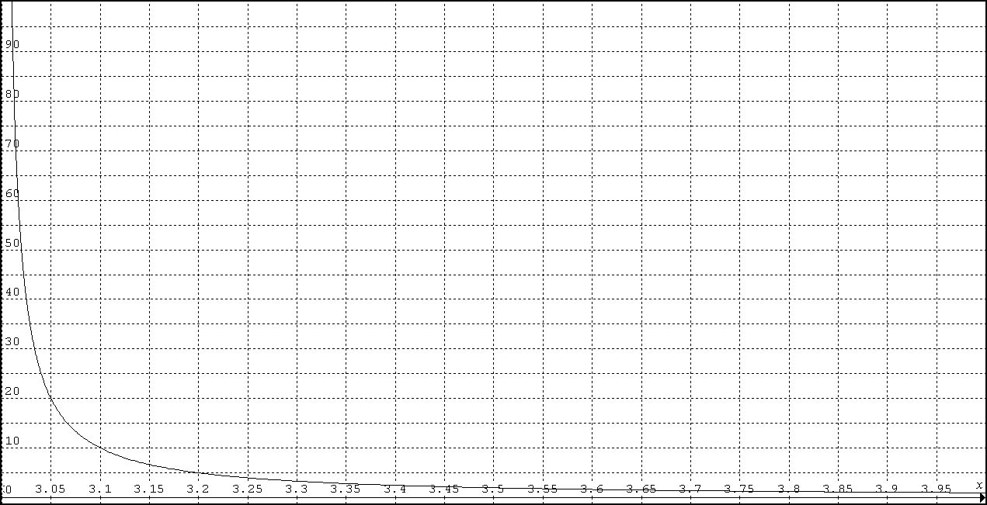

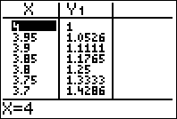 | 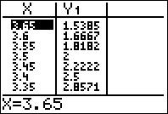 | 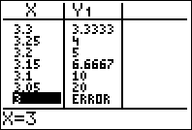
1.3.7: Home Activity Ideas (Teacher)

Idea 1
Consider the repeating decimal 0.9999999…. Represent this decimal as a fraction. Explain the result in terms of limits.

Idea 2
Does a limit exist? A staircase is constructed that has a vertical height of 4 units and a horizontal length of 4 units. Each step has a length of 1 unit horizontally and 1 unit vertically, so there are four stairs. The total of the vertical and horizontal distances is 8 (4 × 1 up and 4 × 1 across). Now, put in twice as many stairs by making each step half as long and half as high. What is the total of the vertical and horizontal distances? Continue to double the number of steps by halving the length and height of each step. Describe the limiting process taking place as the doubling continues, forever.

Idea 3
Describe the limit of the following process. (Do not look for a numerical solution – rather look for a descriptive solution): An equilateral triangle is inscribed inside a unit circle. A circle is inscribed inside the triangle. A square is inscribed inside this circle. A circle is inscribed within this square. A regular pentagon is inscribed inside this circle. A circle is inscribed within the pentagon.

Idea 4
What is the value of the fraction as the division continues? Compare the result with that of Investigation 2 (BLM 1.3.2).

Idea 5
Investigate the area and perimeter of the Sierpinski Triangle as the number of iterations increases.

Idea 6
Investigate the area and perimeter of the Koch Snowflake as the number of iterations increases.

Unit 1: Day 4: Calculating Instantaneous Rates of Change Numerically |  |  |  |  | MVC4U
75 min. |  | Math Learning Goals  - Connecting the average rate of change of a function to the slope of the secant using the expression .  - Connecting the instantaneous rate of change of a function to the slope of the tangent using the expression . |  |  | Materials  - BLM 1.4.1, 1.4.2  - computer and data projector  - The Geometer’s Sketchpad®
Assessment
Opportunities
 | Minds On… | Whole Class → Discussion  Activate prior knowledge of function notation, secant lines, slopes of line segments and average rate of change from MHF4U and previous lessons in this unit.  Use the GSP® sketch Slope Secant.gsp to develop the general expression for the slope of a secant line . |  | The GSP® Secant Slope.gsp  BLM 1.4.1 can be used if no access to The Geometer’s Sketchpad® is possible.  The first page of the GSP® sketch determines the slope of the secant line numerically and the second page develops the general expression.
 | Action! | Pairs → Investigation  Students work in pairs to develop the understanding that the slope of the secant becomes the slope of the tangent as h approaches zero (BLM 1.4.2).  Mathematical Process Focus: Connecting and Communicating  Curriculum Expectation/Observation/Mental Note: Observe students understanding of the connection between the slope of the secant and the slope of the tangent.
 | Consolidate Debrief | Pairs → Think/Pair/Share  Student pairs use the Think/Pair/Share literacy strategy to consolidate understanding of concepts. (BLM 1.4.2)  Summary  When h approaches zero the secant line becomes a tangent line. To find the slope of the tangent line for at x = a you must evaluate .
Exploration  Application |  | Home Activity or Further Classroom Consolidation  Complete practice questions from Worksheet 1.4.2

1.4.1: Secant Slope (Teacher)

Numerically

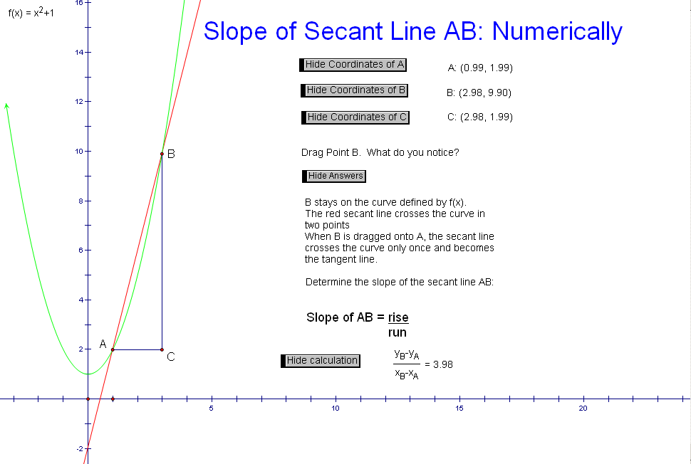

Algebraically

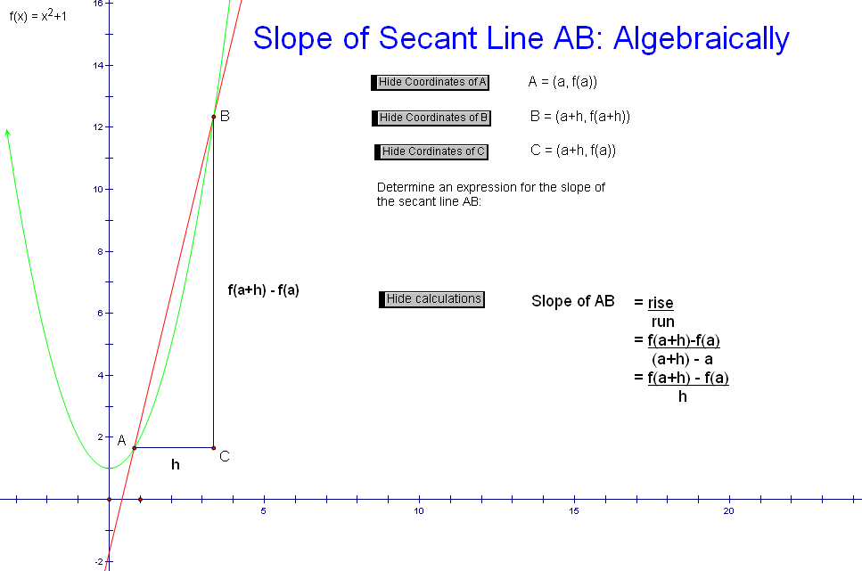
1.4.2: Determining Numerically the Instantaneous
Rate of Change

With a partner, determine the slope of secant lines from a point on a curve to another point where the x value is h units away from the original x value. Calculate slopes of secants for smaller and smaller values of h.

Method 1: Substitute into the Slope of a Secant Expression

Function: Value of a: 3

a | h | a + h
3 | 1 | 4 |  |  | 7
3 | 0.1
3 | 0.01
3 | 0.001
3 | 0.0001

Method 2: Substitute into the Slope of a Secant Expression

Function: Value of a: 3

 | h
 | 1 | 7
 | 0.1
 | 0.01
 | 0.001
 | 0.0001

1.4.2: Determining Numerically the Instantaneous
Rates of Change (continued)

Consolidating Questions
1. What value is the slope of the secant line approaching as h gets smaller and smaller? What does this value represent?

2. What do you notice about the results of the two methods?

3. Explain why the slope of the secant line is changing as the value of h decreases to zero.

4. Which method allows you to find the slope of the tangent to any point for any function?

Extra Practice
Repeat the procedure of Method 1 and Method 2 to determine the slope of the tangent line to the following functions at the given value of x = a.

a) Function: |  | Value of a: 5
b) Function: |  | Value of a: 4
c) Function: |  | Value of a: 2

